Available online at [www.sciencedirect.com](http://www.sciencedirect.com/)



AASRI Procedia 3 (2012) 607 – 612

# 2012 AASRI Conference on Modelling, Identification and Control

Data Mining-based Operation Optimization of Large Coal-fired Power Plants

Ningling Wanga*, Yong Zhangb, Ting Zhanga Yongping Yanga

*a Key Laboratory of Condition Monitoring and Control for Power Plant Equipment, MOE,*

*North China Electric Power University, Beijing 102206,China*

*bShenhua Guoneng Power Group, No.26B Financial Street, Beijing 100033,China*

**Abstract**

Large coal-fired power generation is a complex process characterized as nonlinear and coupling correlation between the levels of equipment, subsystems and function modules. It is therefore difficult to describe the energy-consumption behaviour and optimize the operation parameters under different operation conditions and boundary conditions with conventional methods. With data mining methods such as Support Vector Regression (SVR) and Genetic Algorithm (GA), a huge amount of practical operation data stored in the plant-level Supervisory Information System (SIS) were used to model the energy consumption and optimize the operation parameters for less coal consumption. The results show that the power coal rate reduced significantly under the combination of SVR and GA. The optimal operation program has a practical feasibility, and the whole optimizing process can supply model basis for large coal-fired power units.

© 2012 The Authors. Published by Elsevier B.V. Open access under [CC BY-NC-ND license.](http://creativecommons.org/licenses/by-nc-nd/3.0/)

© 2012 Published by Elsevier B.V. Selection and/or peer [review under](http://creativecommons.org/licenses/by-nc-nd/3.0/) responsibility of American Applied Science Research Institute

Selection and/or peer review under responsibility of American Applied Science Research Institute

*Keywords*: Operation optimization; data mining; coal-fired power plant; SVR; GA

* Corresponding author. Tel.: +8610-61772284; fax: +8610-66491284.

*E-mail address:* [epower2004@163.com](mailto:epower2004@163.com)

2212-6716 © 2012 The Authors. Published by Elsevier B.V. Open access under [CC BY-NC-ND license.](http://creativecommons.org/licenses/by-nc-nd/3.0/) Selection and/or peer review under responsibility of American Applied Science Research Institute doi:10.1016/j.aasri.2012.11.096

## Introduction

Large coal-fired power unit is a complex nonlinear system with more uncertainties to describe the energy-consumption behaviour, evaluate the coal rate for power generation and optimize the practical operation. The operation optimization problem can be described as Model (1), which consists of two parts: a optimum target such as the highest power efficiency or the minimum coal consumption, and a couple of constraints such as the power load, coal quality, ambient factors and operation conditions. The expression of such optimization problem is explicit but it is difficult to determine the optimal targets in operation optimization of power units, especially considering the varying boundary constraints, operation conditions and system features.

*bopt*

 min *f* ( *X* )

*s*.*t*.*gi* ( *X* )  0, *i*

*hj* ( *X* )  0, *j*

 1, 2, , *m* (1)

# 1, 2, , *n*

Where, *X* is the key operation variables affecting the energy consumption of power units;

*f* ( *X* ) is the optimal target function describing the economic performance of power units;

*gi* ( *X* )  0 and *hj* ( *X* )  0 are the constraint conditions demonstrating the ambient and operation conditions of power units.

Commonly used optimal targets mainly cover the designed values from the fabricants of power

equipment, the test benchmark conducted on site and the calculation results based on mathematic modelling of power units. There are several limitations of these methods such as low efficiency, inexplicit description and local optimization features; in addition, they are frequently impracticable, costly and time-consumed, for a power unit is a complex nonlinear system with more uncertainties to describe, evaluate and optimize for different boundary and operational conditions.

The increasing development of measuring, monitoring and information technologies strive a highway for the operation optimization of power units including data processing, uncertainty measuring, intelligent modelling and expert system building[2~5]. Clustering and fuzzy associated rules-based methods are used in process control and individual parameter optimization such as excessive air flow and boiler efficiency[2,5]; neural network (NN) and SVR methods are introduced to model the NOX emission of the coal-fired boiler and the operation parameters are optimized with ant colony optimization algorithm (ACO) and GA method. This made a reference for the operation optimization of power plants.

In this paper, SVR and GA are used to model the coal consumption behaviour and determine the optimum value of operation parameters. GA shows its priorities in two sides: to select the modelling parameters of SVR[4] and to optimize a set of key operation parameters to obtain the optimum values, at which the coal rate for power generation falls into the least under different operation conditions.

## Related knowledge on SVR and GA

* 1. *Overview on Support Vector Regression*

As an emerging technology of data mining, support vector machine (SVM) was originally proposed by Vapnik in 1990s to solve the classification problem, which is based on the VC principle and structure risk minimization principles[3] With a substantial foundation and systematic reasoning; SVR is of the favourable features in unique solution, global optimization and strong generalization. SVR problem is described as:

Given the training samples set: *T x* , *y* , *x* , *y* ,  , *x* , *y X Y n* , where *x * *Rn* ,

1 1 2 2 *n n i*

*yi * *R* ,

*i * 1, 2,

*n* . *xi* is the input variable,

*yi* is the corresponding target value and *n* is the

sample number. The aim of regression modelling is to search in *Rn* for a real-value function *f* (*x*) .

SVR algorithm can be described as the following optimization problem:

# min 1

*w*,*b*, 2

*l*

*w*2  *C*



*i*

*i*

*i *1

*y * *wT *(*x* )  *b*

*(2)*

*i i i*



*s*.*t wT *(*x* )  *b * *y*



*i*

*i i*

# , * 0

Where

*i i*

*n*

 ( *)(*x* ) is the adjustable weight vector,

*i i i*

*i *1

*C * 0 is the penalty factor used to

ensure the smoothness and training accuracy of *f* (*x*) , *  ( , *,  , *)*T* is the slack variable to relax

1 1 *l l*

the constraints in (2),  can be used to regulate the fitting accuracy of model. Where K is the kernel matrix

*  * *T*



and *K* (*xi* , *xj* ) (*xi* ), (*xj* )

thus the derived model is 

.Solve model (4) and obtain the optimum solution

1, 1 , *l*,  *l* ,

*n*

*f* (*x*) (*i i*1



*)*K*(*x*, *x* )  *b*

*(3)*

*i i*

In SVR model, there are three factors, i. e. the type of kernel function, kernel function parameter and punish coefficient, dramatically affecting the accuracy, complexity and generalization ability of the model built with SVR. For this, it is important to select and optimize the above parameters[4].

* 1. *Overview on Genetic Algorithm*

GA is one of the optimization algorithms, which is derived from Darwin's genetic choice and biological evolution process of natural selection. GA is a global optimization algorithm with strong commonality, robustness and promising applications in machine learning, process control, economic forecast and optimization[9~10]. It consists of the following 7 main components: string coding, initialization, fitness function, selection operation, crossover operation, mutation operation and stop criterion.

* 1. *GA-based model parameter selection and operation optimization*

As shown in Figure 1, GA is introduced in this paper for both the parameter selection of SVR model and the optimization of operation parameters. The optimization process includes the following six steps:

Step 1  Initial parameter Settings. Preset GA algorithm population scale, selection operation, crossover operation and mutation operation and termination evolution algebra. Choose operation selection scale selection operator, crossover operation using single point crossover operator, mutation operation use basic for mutation operator.

Step 2  Coding and the generation of initial population. According to stay optimization parameter , C,  and operation parameters of the optimal interval and precision requirements, to determine to optimize parameters of the chromosome length, the parameters are binary coding.

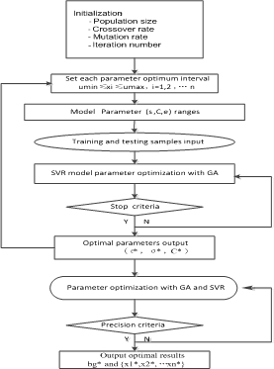

Fig 1 Flow chart of GA-based model parameter and operation optimization algorithm

Step 3  Input the training sample and test sample, set up fitness function, the SVR model parameters optimization; Step 4  If meet the termination conditions, the output SVR optimal model (*, C*, *), if not satisfied, return to step 3; Step 5  If meet the termination conditions, the output SVR optimal model (*, C*, *), if not satisfied, return to step 3; Step 6  Meet maximum number of iteration, the output bg * and.bg* and

x* = *x* * ,*x* * ,  ,*x* *

1 2 *n* .

## Case analysis and application research

* 1. *case unit and data set description*

A 600MW subcritical coal-fired power unit is selected as the case unit. The boiler is of HG-2023/17.6- YM4 type, subcritical, -type layout, intermediate reheat controlled circulation drum-type; the steam turbine is of N600-16.7/537/537-I type, 600MW subcritical condenser steam unit, single intermediate reheat, four cylinders, quadruple-flow and single-shaft.

* 1. *Operation parameter optimization based on GA*

The GA was used to optimize unit actual operation parameters, the objective function is to minimum

power supply coal consumption of the unit, namely opt_bg

*f* (*x*1, *x*2 ,..., *xn* ) . For the thermal power units

in operation, the operators can improve the operation performance of power units by adjusting the controllable parameters such as the main steam temperature, main steam pressure, reheated steam temperature, reheated

steam pressure. The ranges of operation parameter set

x=  *x*1,*x*2 ,  ,*xn*

is shown in (4), where x1 is main

steam temperature, x2 is reheat steam pressure, x3 is main steam temperature, x4 is main steam temperature, x5 is condenser end difference, x6 is vacuum of condenser, x7 is exhausted gas temperature, x8 is oxygen content in gas, x9~x15 is respectively1 # heater terminal temperature difference (TTD), 2 # heater TTD, 3 # heater TTD, 5 # heater TTD, 6 # heater TTD, 7 # heater TTD, 8 # heater TTD, respectively. The parameters of GA are set as: population size selection for 50, coding method for binary coding, crossover probability was 0.8, the variation probability is 0.1, eolution algebra for 150 generations.

16  x1  16.7, 3  x2  4

530  x3

 545, 530  x4

 545

# s. t. 3 x5 7, 0.88 x6 0.95

100  x7 130, 3  x8  4

*(4)*

# -2 x9 x15 5

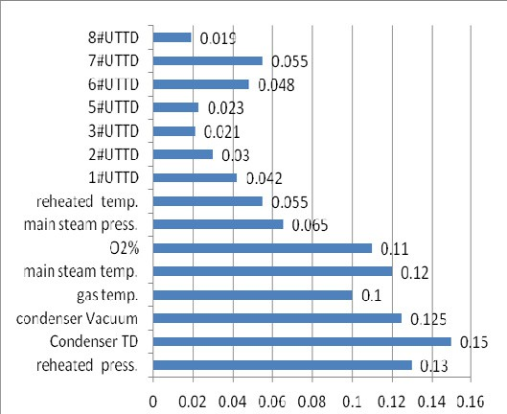The operation optimization is conducted under the conditions of 100%THA, 75%THA and 50%THA. The optimization process under 50%THA based on GA is shown in Figure 2, and the significance of key operation parameters is shown in Figure 3.

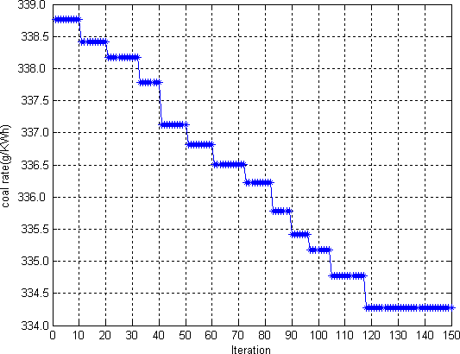

Fig 2 Optimizing process of GA under 50% THA Fig 3 Significance of parameters under 50% THA Table 1 shows and set at 100% condition, 75% condition, 50% conditions set parameter actual operation

value and the optimization of target value.

## 4. Conclusion

1.  The operation optimization of coal-fired power units can be realized by GA, and the coal rate under 100% THA, 75% THA and 50%THA is reduced by 2.87 g/kWh, 3.93 g/kWh, 5.80 g/kWh, i. e. 0.93%, 1.24% and 1.71%, respectively. There is larger energy-saving potential under lower power load..
2.  Under different working conditions, affects the unit energy consumption characteristics of different key variables. In the unit security constraint condition permission scope, increasing unit main steam pressure, main steam temperature, reheat steam temperature parameter value, smoke temperature decrease reduced, but reduces the power supply coal consumption bg. But smoke oxygen in 100%, 75% conditions

have rise.

Table 1. Comparison of realizable optimal values and operation values

|  |  |  |  |  |  |  |  |  |
| --- | --- | --- | --- | --- | --- | --- | --- | --- |
| THA | | | 75% THA | | | 50% THA | | |
| Mian parameters | actual | Optimal | actual |  | Optimal | actual |  | Optimal |
|  | value | value | value |  | value | value |  | value |
| Main steam press. (MPa) | 16.20 | 16.48 | 14.2 |  | 14.84 | 8.470 |  | 9.42 |
| Reheat steam press.(MPa) | 3.41 | 3.69 | 2.592 |  | 3.31 | 1.870 |  | 2.47 |
| Main steam temp.( ) | 541.46 | 541.82 | 537.86 |  | 538.36 | 533.81 |  | 534.15 |
| Reheat steam temp.( ) | 540.55 | 538.73 | 536.83 |  | 528.76 | 526.78 |  | 525.78 |
| Condenser TD | 4.60 | 4.50 | 12.626 |  | 5.451 | 11.85 |  | 7.40 |
| Condenser Vacuum % | 0.93 | 0.95 | 0.92 |  | 0.94 | 0.91 |  | 0.93 |
| Exhausted temp. | 124.20 | 118.88 | 124.26 |  | 116.03 | 111.32 |  | 107.82 |
| O2% in gas ppm | 3.86 | 3.94 | 4.50 |  | 4.60 | 6.32 |  | 5.45 |
| 1 # heater TTD | 2.04 | 1.54 | 0.53 |  | 0.49 | -1.92 |  | 0.43 |
| 2 # heater TTD | 2.44 | 1.15 | 0.47 |  | 0.46 | -1.75 |  | 0.89 |
| 3 # heater TTD | 1.547 | 1.18 | -0.58 |  | 1.84 | -2.21 |  | 1.34 |
| 5 # heater TTD | 7.029 | 2.86 | 7.020 |  | 3.52 | 6.27 |  | 3.58 |
| 6 # heater TTD | 7.505 | 3.29 | 7.772 |  | 3.73 | 9.07 |  | 3.92 |
| 7 # heater TTD | -4.285 | 4.21 | -3.394 |  | 3.32 | -3.48 |  | 4.15 |
| 8 # heater TTD | 2.803 | 2.79 | 3.737 |  | 2.25 | 5.62 |  | 3.09 |
| bg g/KW •h | 307.36 | 304.49 | 316.75 |  | 312.82 | 340.08 |  | 334.28 |
| bg g/KW •h |  | 2.87 |  | 3.93 |  |  | 5.80 |  |
| bg/ bg % | 0.93% | | 1.24% | | 1.71% | | | |

1.  In the guarantee to the steam turbine the last stage blade not cause damage conditions, reasonable improve condenser vacuum degree, reduce steam turbine exhaust temperature, saving steam, improving efficiency, reduce the power supply coal consumption.

## Acknowledgements

This paper is supported by 973 Project (2009CB219801) and the Fundamental Research Funds for Central Universities (12QN05).

## References

1. Yang Yongping, Guo Xiyan, Wang Ningling. Power generation from pulverized coal in China[J].

Energy, 2010, 35(11): 4336~4348

1. Ligang Zheng, Shuijun Yu, Minggao Yu. Monitoring NOx Emissions from Coal-Fired Boilers using Generalized Regression Neural Network[C]. IEEE, China, 2008.
2. ZHOU Hao, ZHU Hong-bo, CEN Ke-fa *et a1*. An On-Line Boiler Operating Optimization System Based on the Neural Network and the Genetic Algorithms[J]. POWER ENGINEERING, 2010, 35(11): 4336~4348
3. Wang Ningling.Theoretical Research Data Mining-based Energy-saving Diagnosis and Optimization for Large Coal-fired Power Units [D]. North China Electric Power University
4. Hao Zhou, JiaPei Zhao, LiGang Zheng, *et al*. Modelling NOx emissions from coal-fired utility boilers using support vector regression with ant colony optimization[J]. Engineering Applications of Artificial Intelligence , 2012,147–158